## [Utils]條件欄位後端繁簡轉換查詢2

Shared by: Gilbert Lin

Problem:

[B21]職稱與職工對照查詢 人員"黃啟恒" 輸入全名時會filter不到

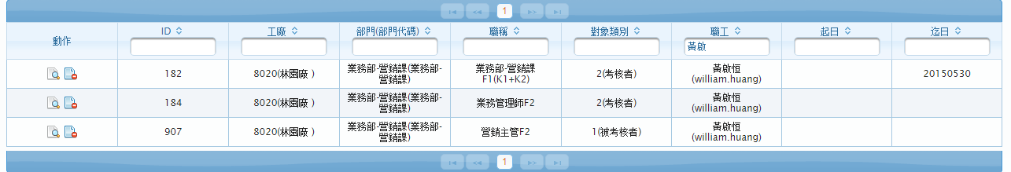

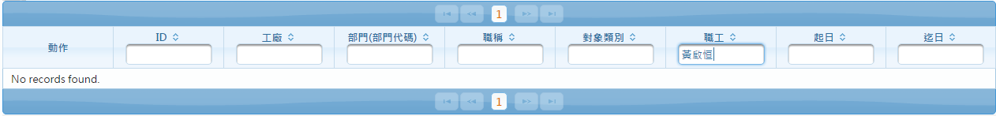

**Solution:**

參考commonReport利用 jcc-bate-0.7.3.jar取得簡繁體陣列取代原zhcoder.jar

**converterZhUtils.java(詳細程式碼請看**Ref.**)**

/**

* 取得簡繁體陣列

* @param inputString 簡體或繁體

* @return 簡繁體陣列 or 原字串

*/

public static String[] converterZhCode(String inputString){

String[] materialNames = null;

try {

if (org.apache.commons.lang.StringUtils.isBlank(inputString)) {

return null;

}

JChineseConvertor jChineseConvertor = JChineseConvertor

.getInstance();

if (isWorkWithZhCoder) {

**String inputString_s = jChineseConvertor.t2s(inputString);**

**String inputString_t = jChineseConvertor.s2t(inputString);**

**//若inputString為繁體, materialNames[1]為簡體**

**//若inputString為簡體, materialNames[1]為繁體**

**if(inputString.equals(inputString_t)){**

**materialNames[0] = inputString;**

**materialNames[1] = inputString_s;**

**}else if(inputString.equals(inputString_s)){**

**materialNames[0] = inputString;**

**materialNames[1] = inputString_t;**

**}**  }

} else {

materialNames = new String[1];

materialNames[0] = inputString;

}

return materialNames;

} catch (IOException ex) {

java.util.logging.Logger.getLogger(ConverterZhUtils.class.getName()).log(Level.SEVERE, null, ex);

}

return materialNames;

}

**usage**

**NativeSQLUtils.java**

**…**

//料號名稱(繁簡查詢)

**String[] values = ConverterZhUtils.converterZhCode(pValue);**

…